1.1: Signin module will have a username and password field. User should be able to enter their credentials on those fields and click on Login for accessing their accounts

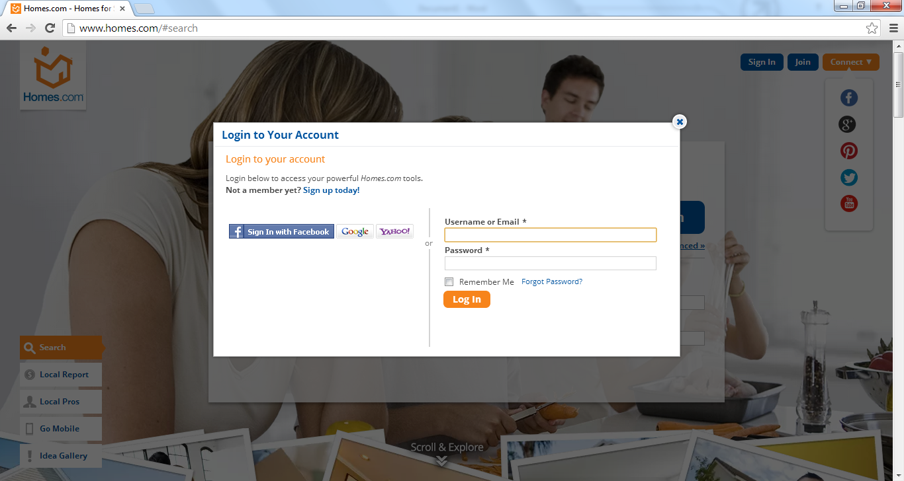

1.2. There should be a ‘forgot password’ link, users should be able to click and retrieve their password through this link.

1.3

……………………….